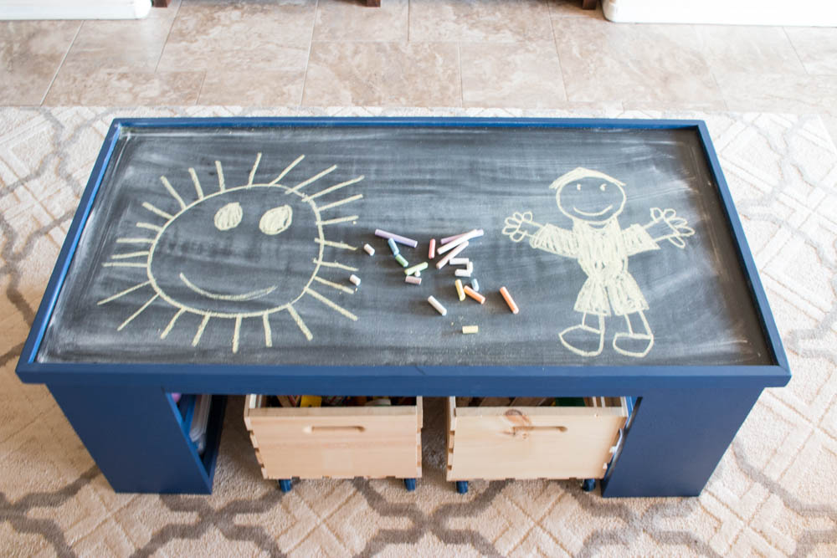

Kids Activity Table

Reversible table top with two book shelves. Overall color can be natural wood or a particular color. Table top can be customized for chalkboard, dry erase, or lego. Chairs or benches can be added.

24.75” (w) x 49.5” (L) x 22” (T)

$80-$110 Depending on customization

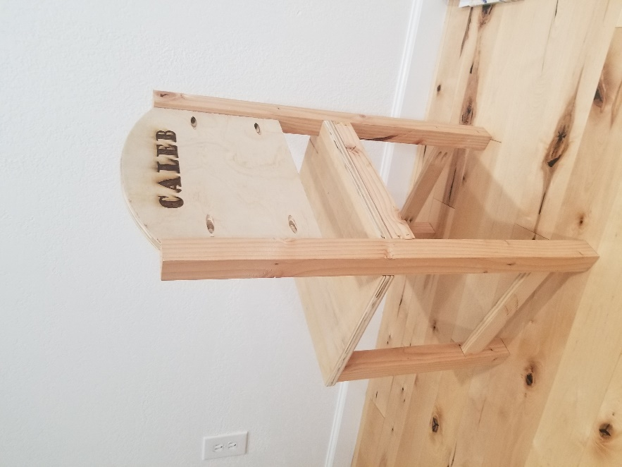

Kids Chair

Can be natural, stained or painted. Name or design customization possible. Fits with activity table.

$15 - $23

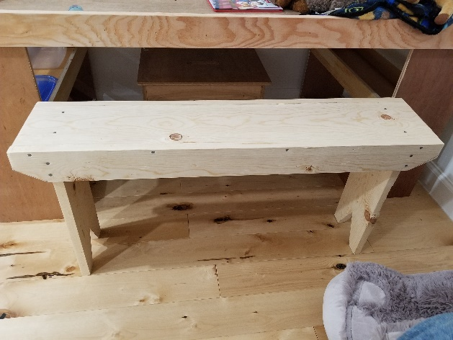

Kids Bench

Can be stained, painted, or natural. Name or design customization possible. Seats 2 & fits with activity table.

32” (L) x 14” (T) $16

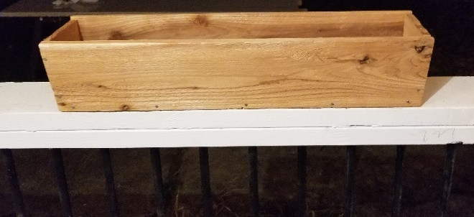

Portable Cedar Planters

5.5” Tall & Wide. Lengths vary with pricing.

Bases: 14” ($8) 20” ($12) 26” ($16)

Whole set of 3 for $30

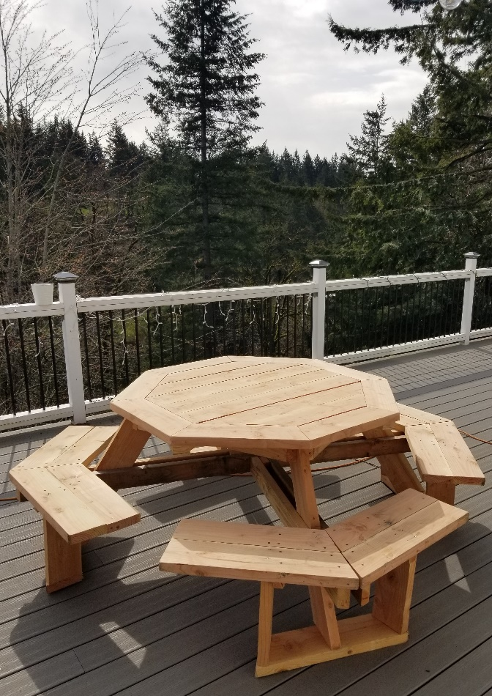

Octagon Picnic Table

Can be natural, stained, or painted

Seats 8 adults

Price $400 - $795 Depending on wood type & stain

View not included unless you come visit me in Boring ☺

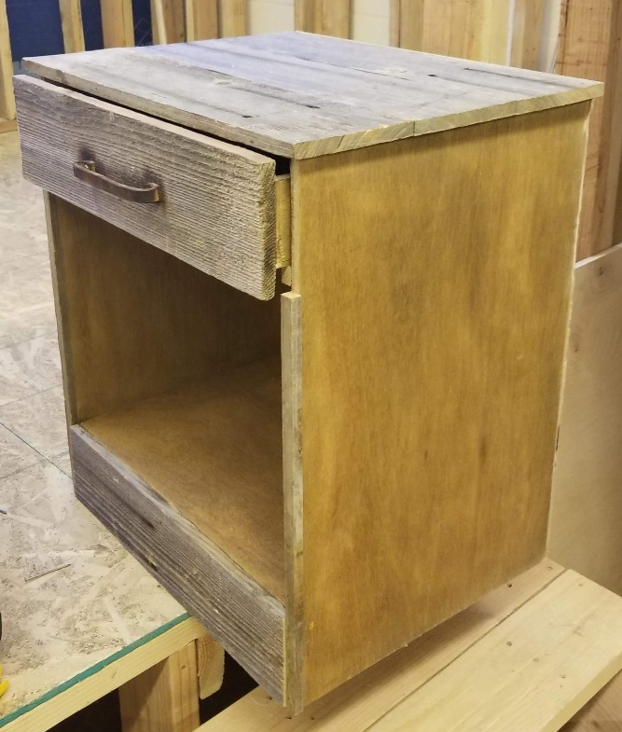

Rustic End Table

Only 2 available!

$70 each or $125 pair

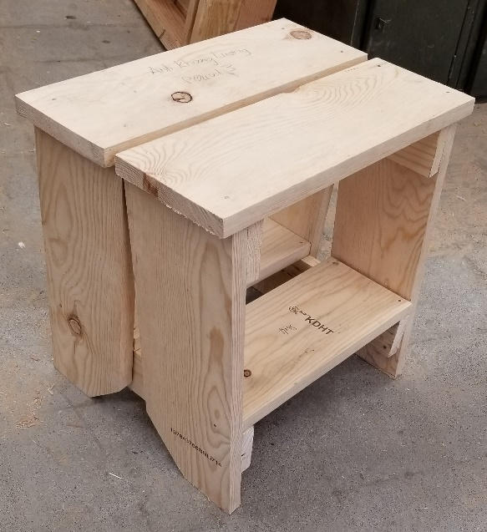

Step Stool/ Plant Stand

Can be stained, painted, or natural

16” Wide & Tall

$15 - $20

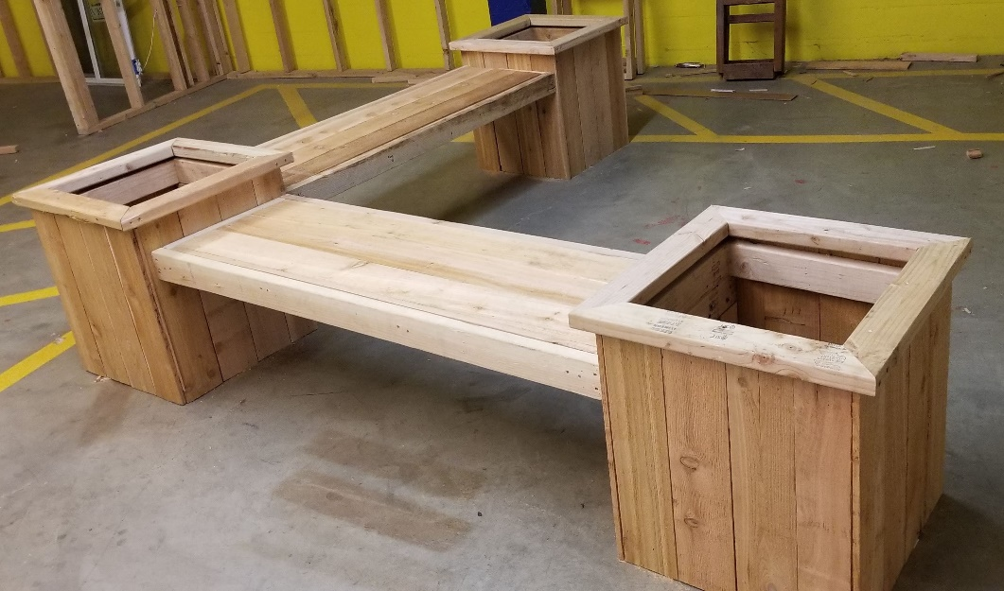

Cedar Bench Planter

2’ x 2’ Planters 6’ x 6’ overall

Overcome the pandemic & spruce up your outdoors

Natural or Stained

$275

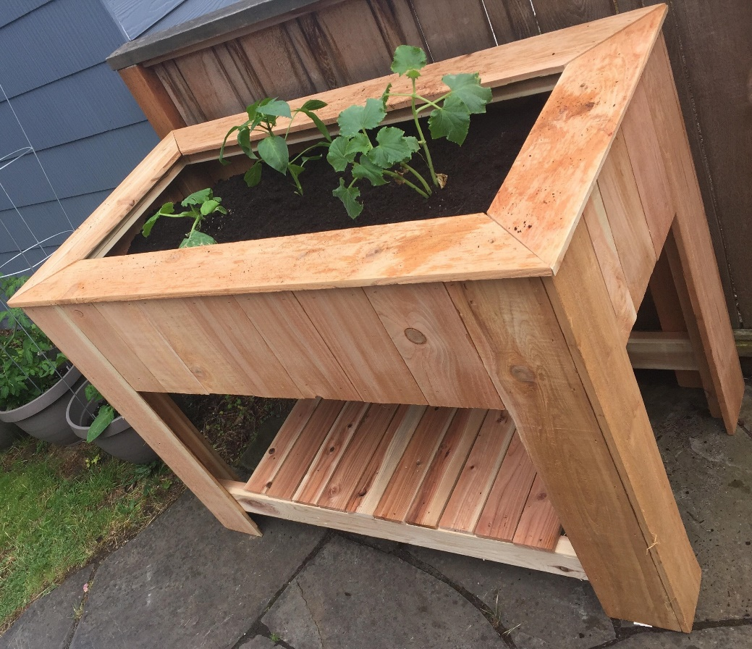

Cedar Bench Planter

2’ (W) x 4’ (L) x 3’ (T)

Overcome the pandemic & spruce up your outdoors

Natural or Stained

$135

Storage Sheds upon request